- Create VPC with 2 private and 2 public subnets.
- Go to VPC → Your VPCs → Create VPC, choose VPC only, name it lab-vpc, set CIDR 10.0.0.0/16, and click Create VPC.
- Go to VPC → Subnets → Create subnet and select lab-vpc.
- Add four subnets with Add new subnet:
  - public-subnet-1: ap-southeast-2a, 10.0.1.0/24
  - public-subnet-2: ap-southeast-2b, 10.0.2.0/24
  - private-subnet-1: ap-southeast-2a, 10.0.3.0/24
  - private-subnet-2: ap-southeast-2b, 10.0.4.0/24
- Click Create subnet.
- Go to Internet gateways → Create internet gateway, name it lab-igw, then click Actions → Attach to VPC and select lab-vpc

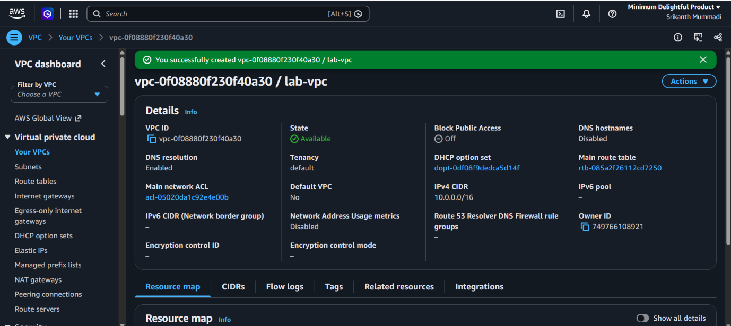

2. Enable DNS Hostname in VPC.
- Go to VPC → Your VPCs and select lab-vpc.
- Click Actions → Edit VPC settings.
- Under DNS settings, tick Enable DNS hostnames (leave Enable DNS resolution ticked).
- Click Save.

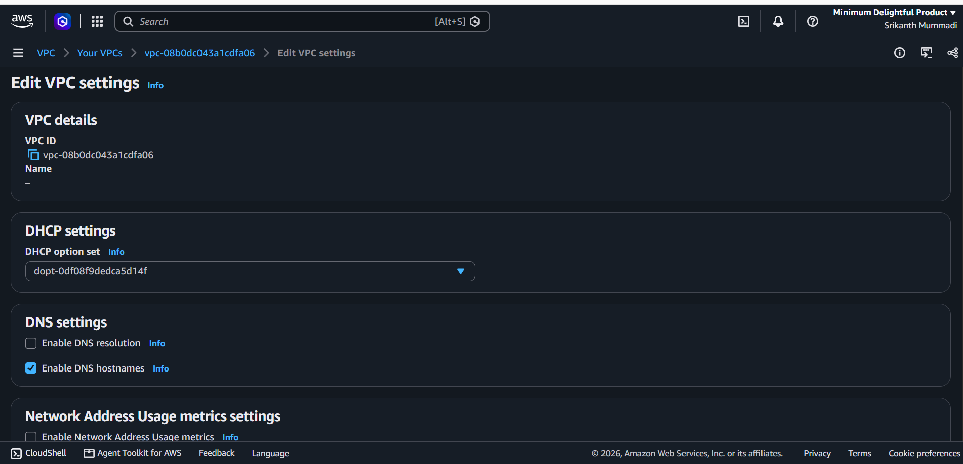

3. Enable Auto Assign Public IP in 2 public subnets.
- Go to VPC → Subnets and select public-subnet-1.
- Click Actions → Edit subnet settings.
- Tick Enable auto-assign public IPv4 address and click Save.
- Repeat steps 1-3 for public-subnet-2.

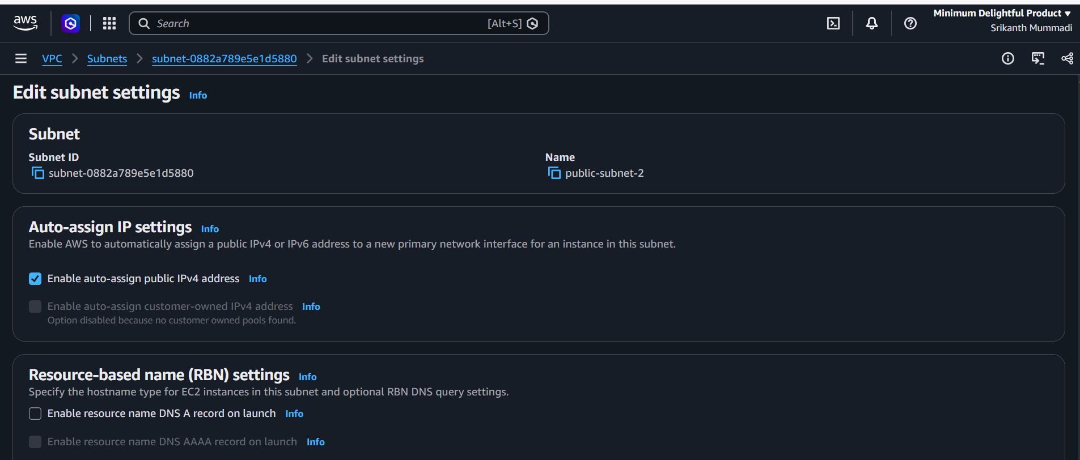

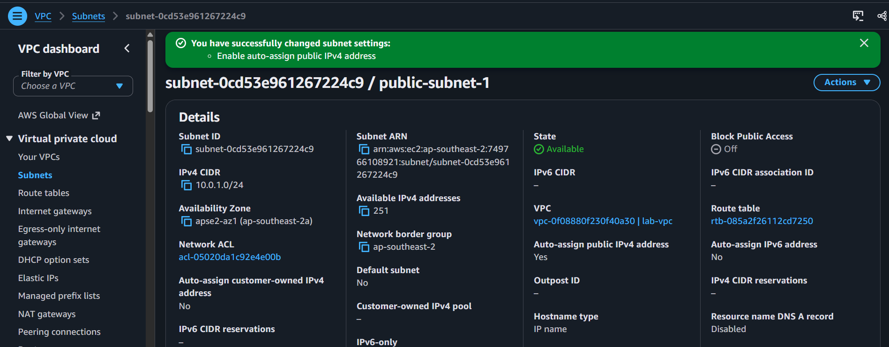

4. Add 2 private subnets in private route table.
• Open AWS Console → VPC.
• Create the first private subnet.
• Create the second private subnet in a different Availability Zone.
• Navigate to Route Tables.
• Create a private route table.
• Select the private route table.
• Open Subnet Associations.
• Click Edit Subnet Associations.
• Select both private subnets.
• Save the associations.
• Verify that both subnets are associated with the private route table.

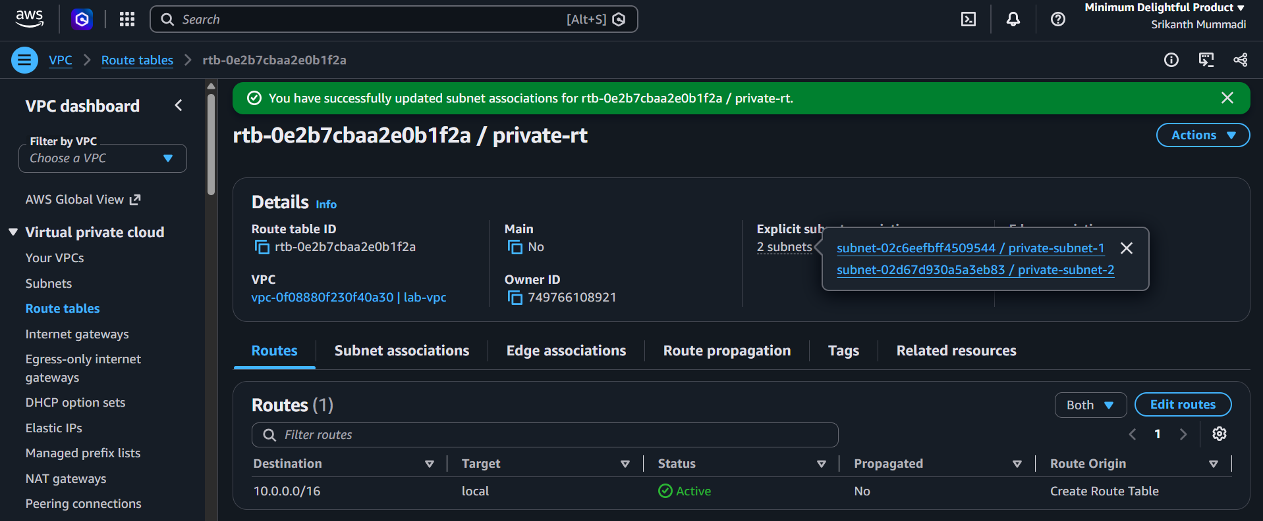

5. Add 2 Public subnets in private route table.
Open AWS Console → VPC.
Navigate to Subnets.
Create the first public subnet.
Create the second public subnet in a different Availability Zone.
Navigate to Route Tables.
Select the route table you want to use.
Open Subnet Associations.
Click Edit Subnet Associations.
Select both public subnets.
Save the associations.
Verify that both public subnets are associated with the route table.

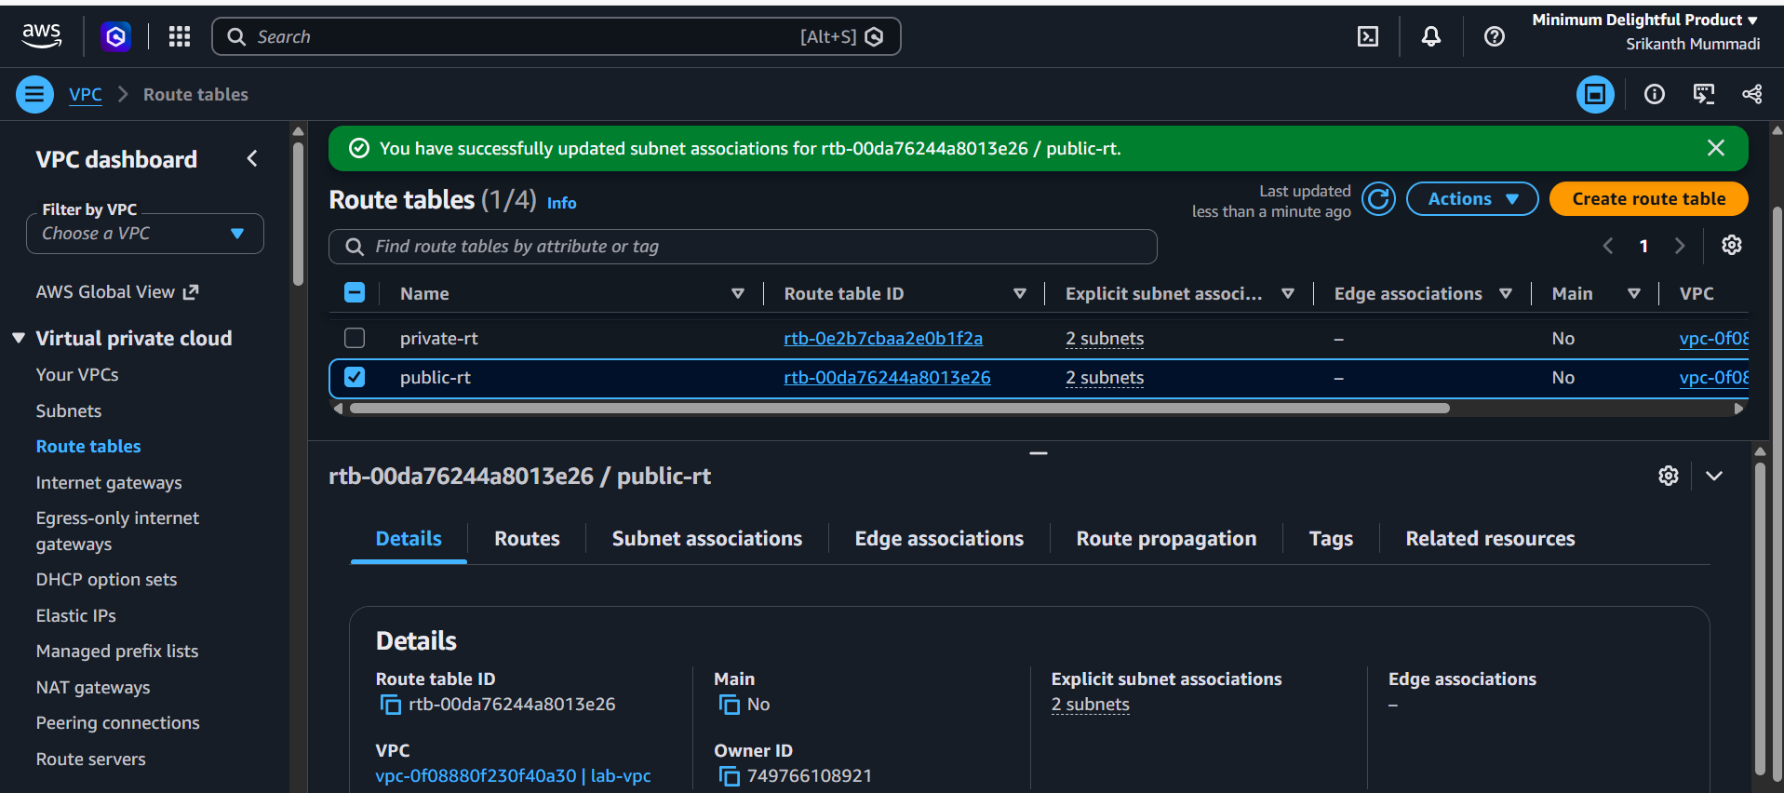

6. Public route table will have the routes to internet and local.
Open AWS Console → VPC.
Navigate to Route Tables.
Select your Public Route Table.
Open the Routes tab.
Click Edit Routes.
Add a new route.
Enter destination as 0.0.0.0/0.
Select Internet Gateway (IGW) as the target.
Ensure the local route is present (e.g., 10.0.0.0/16).
Save changes.

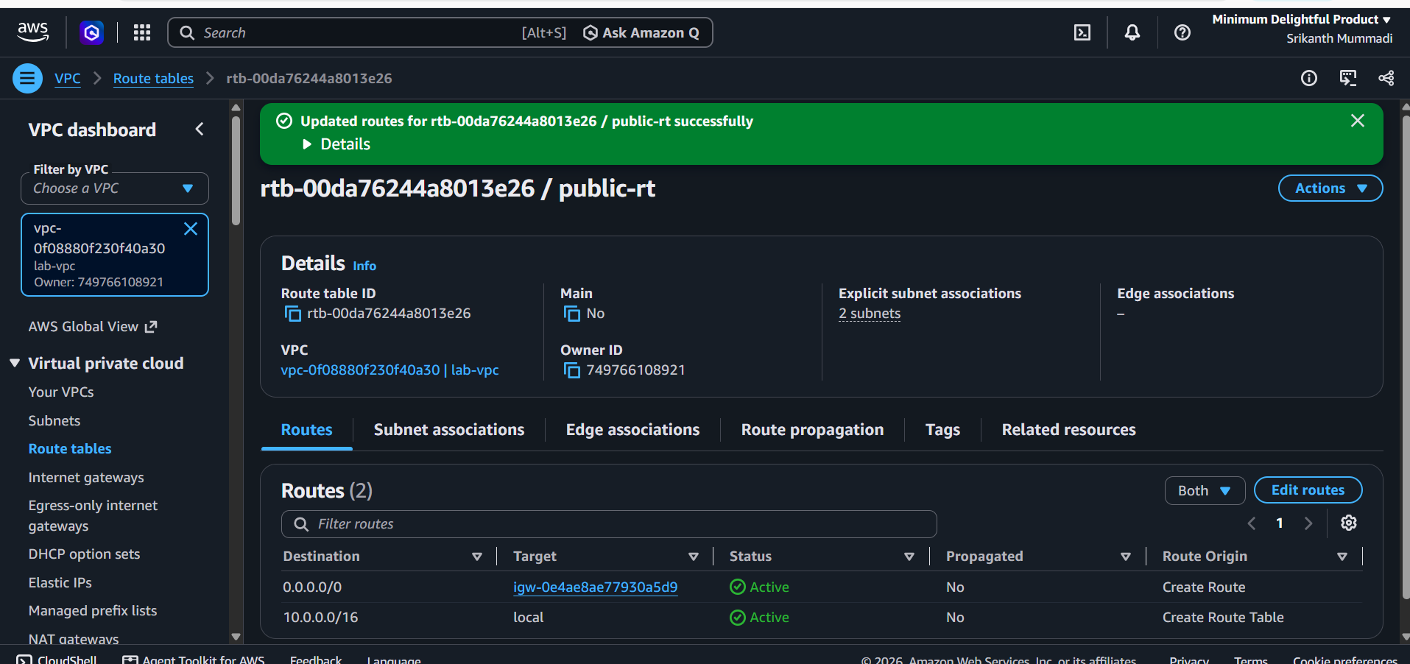

7. Create EC2 in public subnet with t2.micro and install PHP.

Open AWS Console → EC2.
Click Launch Instance.
Enter the instance name.
Select an Amazon Linux AMI.
Choose instance type c7i.flex.large(I choose this because I don’t have t2 micro).
Select or create a key pair.
Configure network settings.
Select your VPC.
Select the Public Subnet.
Enable Auto-assign Public IP.
Configure the Security Group.
Allow SSH (Port 22) and HTTP (Port 80).
Launch the EC2 instance.
Connect to the instance using SSH.
Update the system packages.
Install PHP.
Verify the PHP installation.
Start and enable the web server (Apache).
Test PHP using a browser.

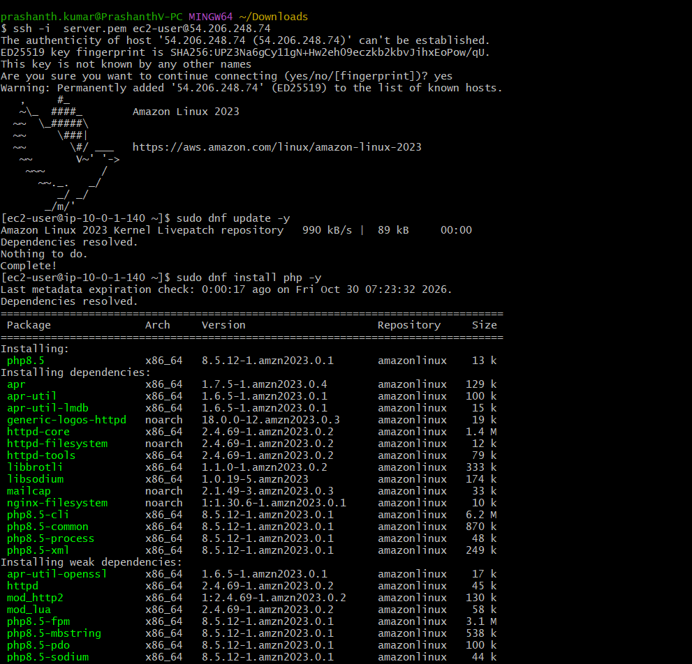
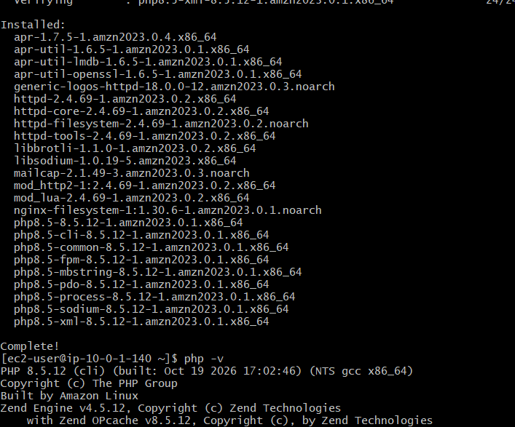

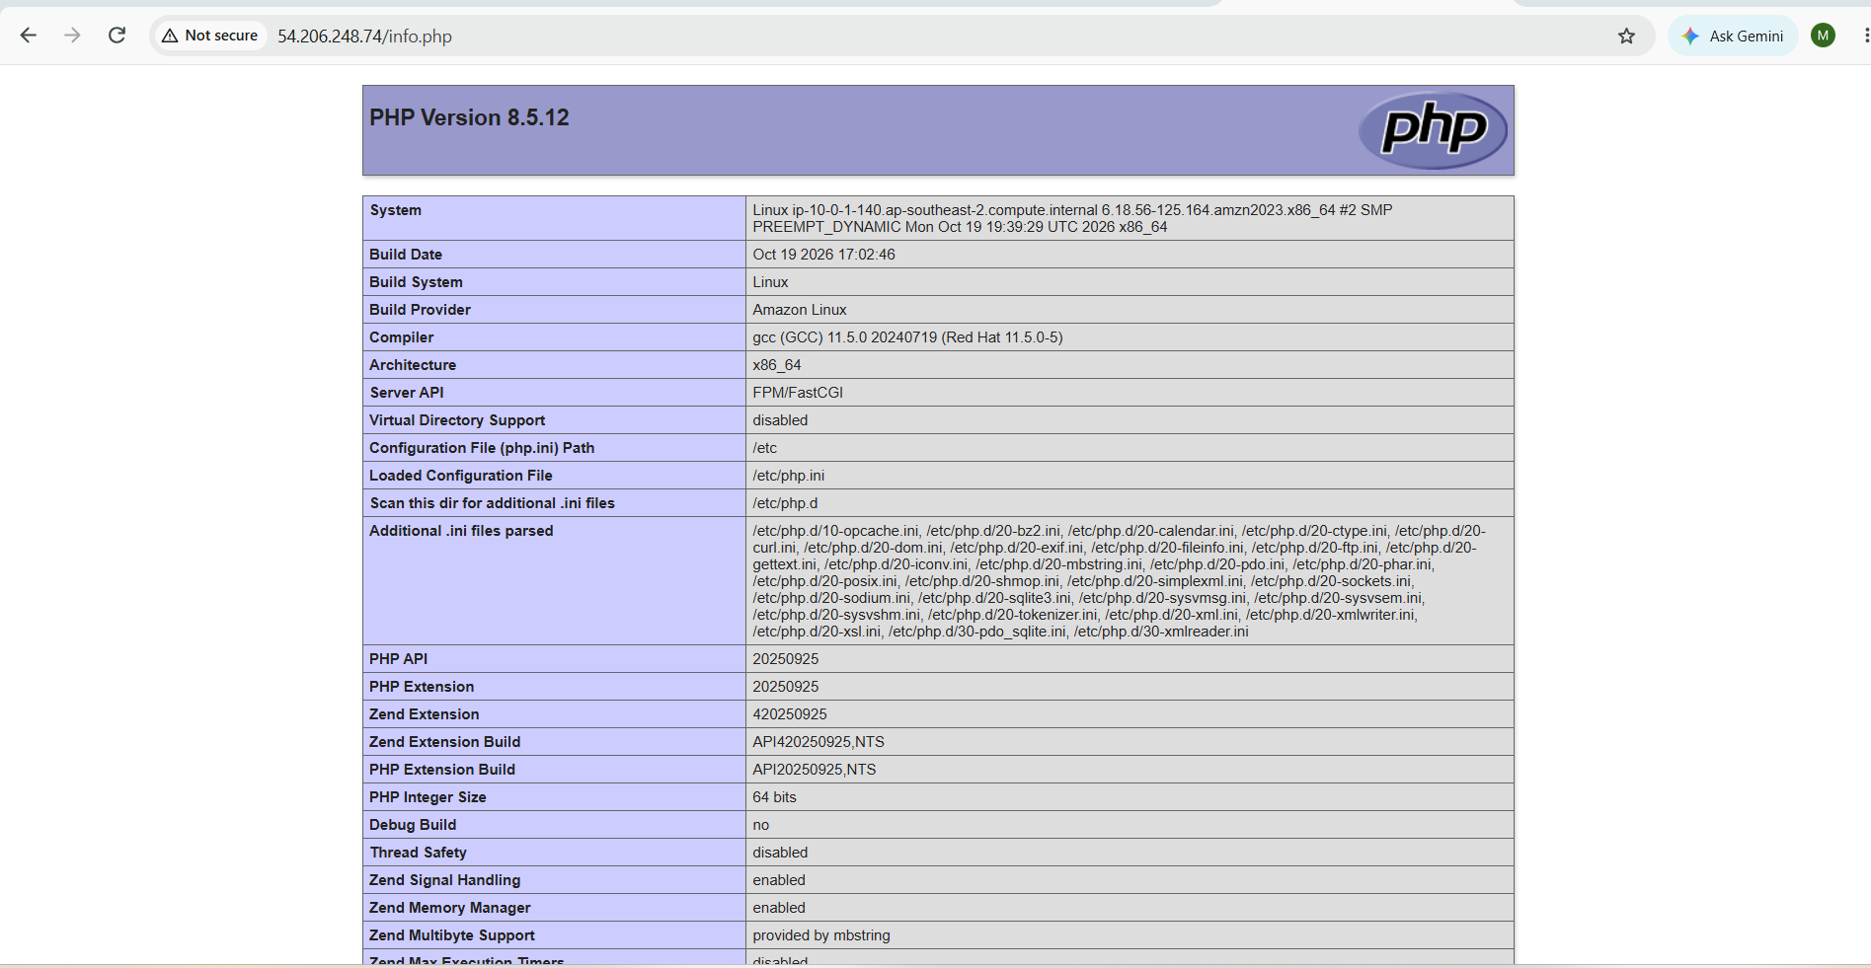

8. Configure NAT gateway in public subnet and connect to private instance.

Created NAT gateways
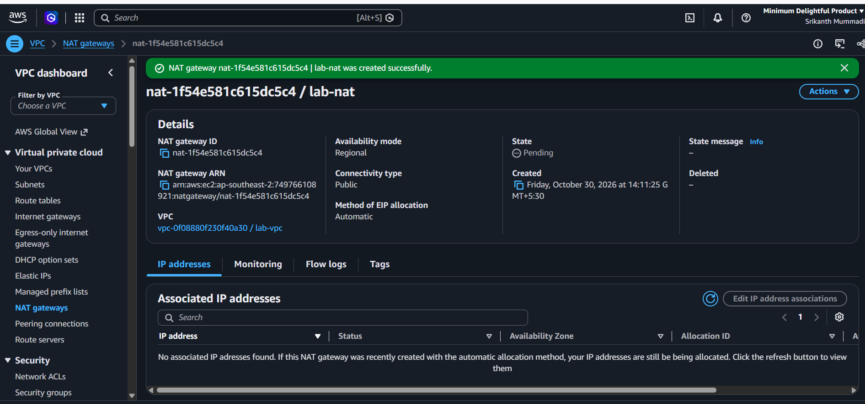
Created Route tables


